Flow in the Factory

The flow in the factory is important for the overall efficiency of the factory. When looking at the efficiency, it also involves looking at the planning for the parts and analyzing the given data for the best possible production sequence. The flow between the machines comes in to reduce the time the parts have to be transferred between machines, and thus keeping the idle times small.

As the size of the parts for the crane are in a completely different range as the old parts that are manufactured, they will have separate production cells in the factory. The machines in these cells will at first only focus on the production of the crane parts. The first iteration of the lay-out for these machines will look similar to the figure below:

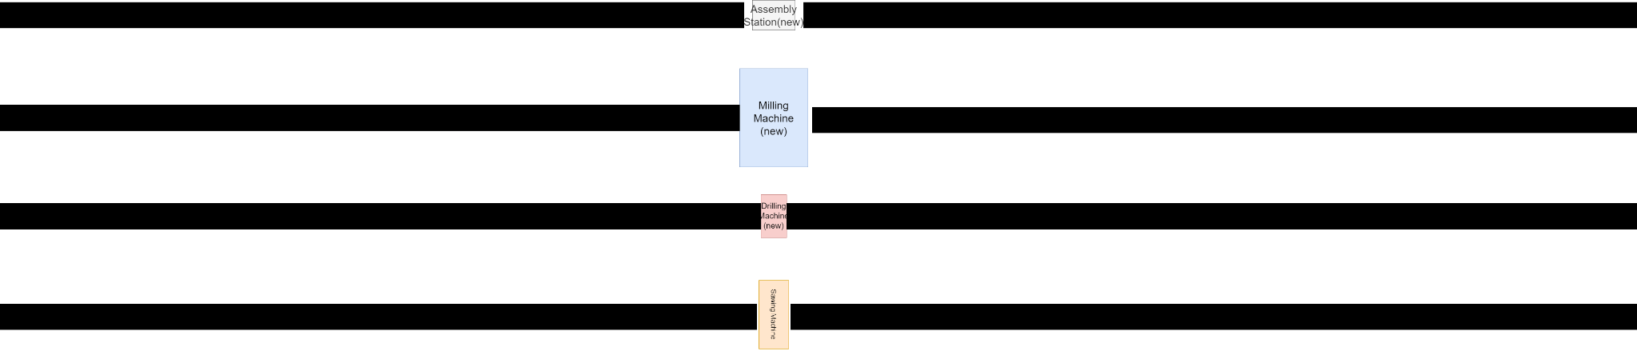

As the parts of the crane are all slender members, it is not space efficient to put all the machines in one line, as this will be quite long. Assumed for this design is that it is not possible to perform 2 or more machine operations simultaneously. The black lines shown in the picture above are conveyor belts that move the parts through the machine. Once an operation is done the part is transferred from the 1 conveyor belt to the other, which can be either done by wheels between the conveyor belts or lifting the entire part. For all the crane parts, the machine sequence is the same, so 1 layout is good.